Lesson-1.1

Solidity is the programming language of Ethereum blockchain. We can write Smart Contracts for ethereum using solidity.

The main network is also called **Homestead.**

The main network is earlier called **frontier.**

Different test networks are Rinkeby,Ropsten and Kovan etc.

We can set up a Private **Network** using an Ethereum **client.**

**Consortium Network**:

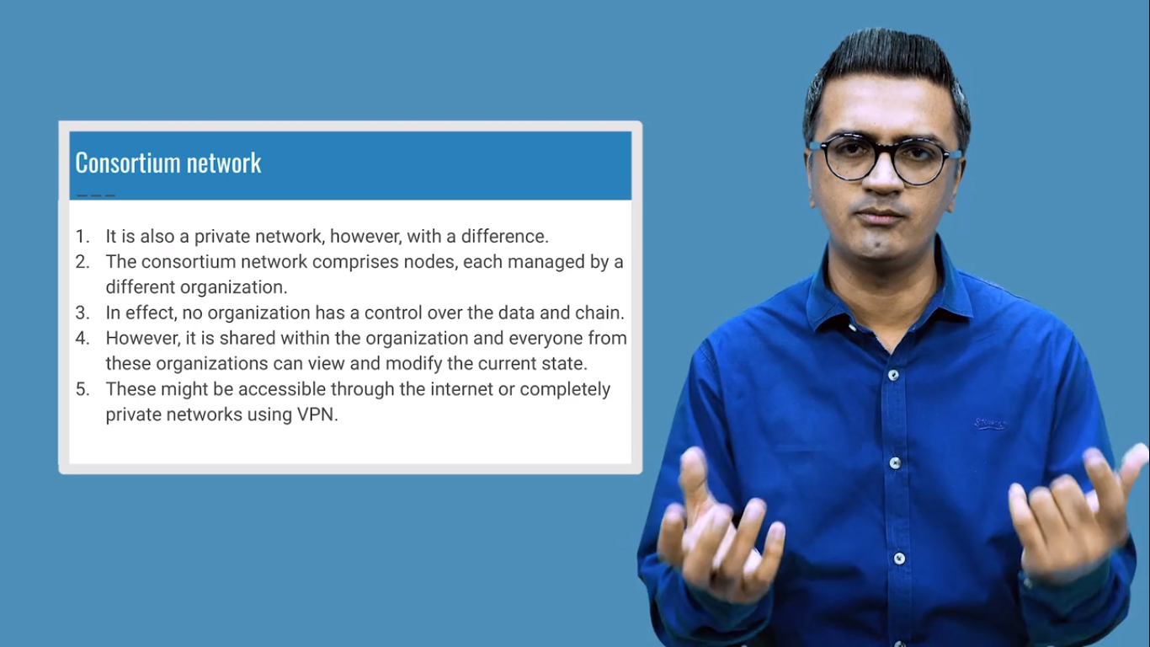

**Tools Required:**

To upload the smart contract or the code to the main or test network we need one of the **clients** which help us to publish the contract to the blockchain Geth and ganache are the clients.

Geth is a CLI tool which we can use for test,main or private blockchain.

Ganache produces the local blockchain(we can access the blockchain without the internet this blockchain will be running to your own machine) only.

**Truffle** provide the whole Project Management (project structure,architecture ,folder structure and also help to upload the code )

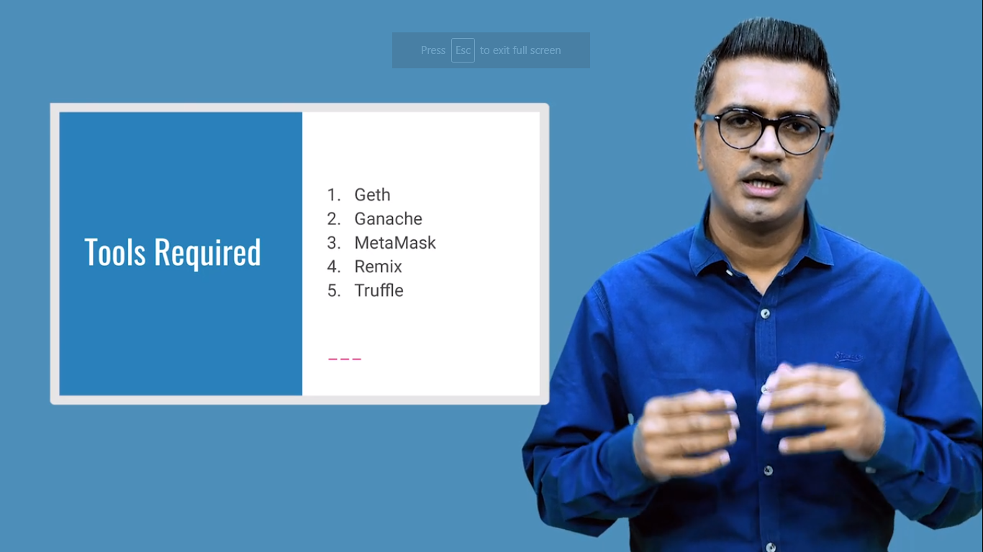

**Ganache** provides the facility that you create your own blockchain network without the internet.

Meta Mask directly injects the web3 into your browser so the code or smart contract can directly upload to the test network.

**GETH:**

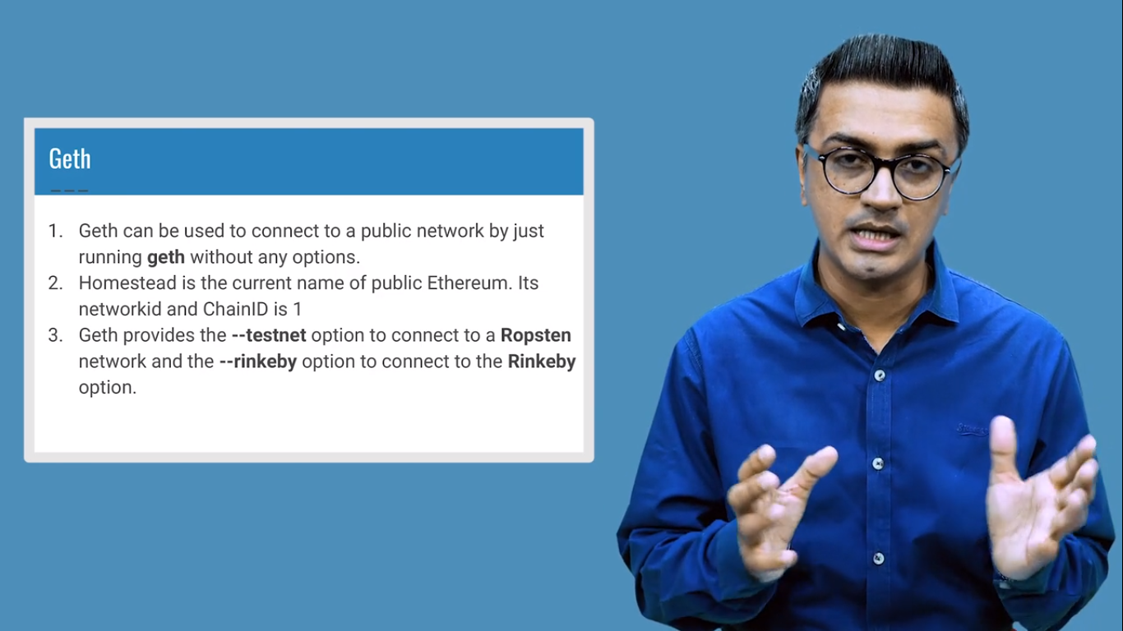

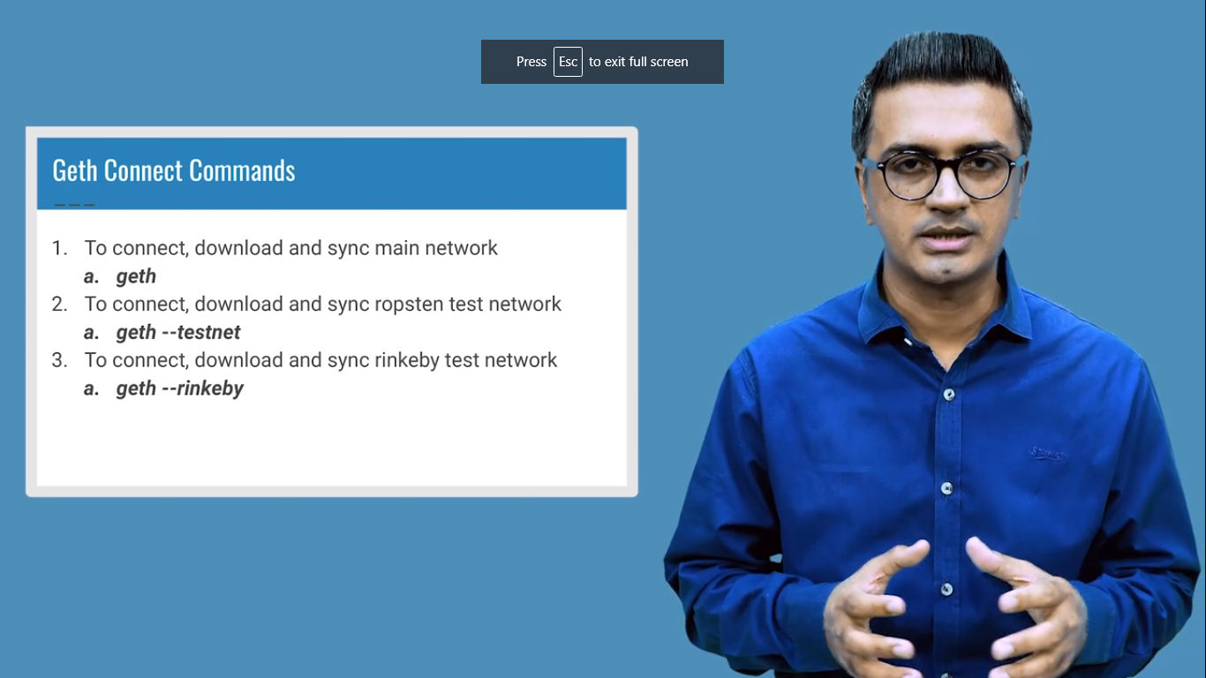

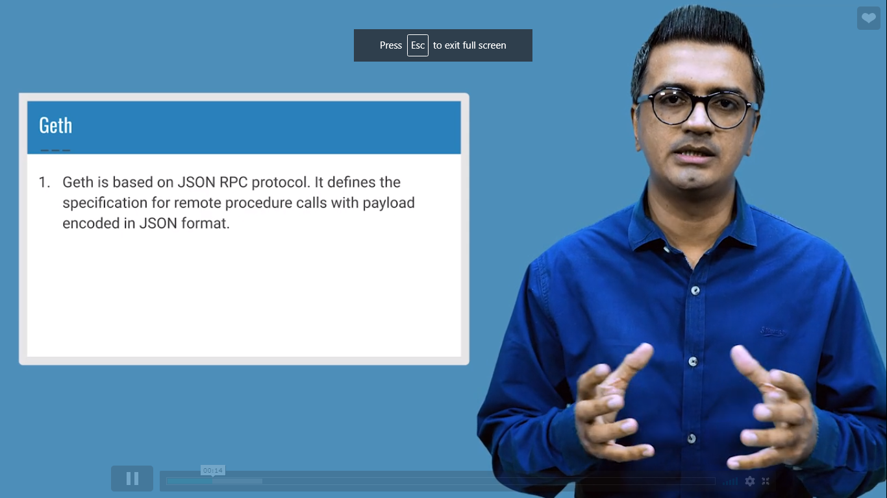

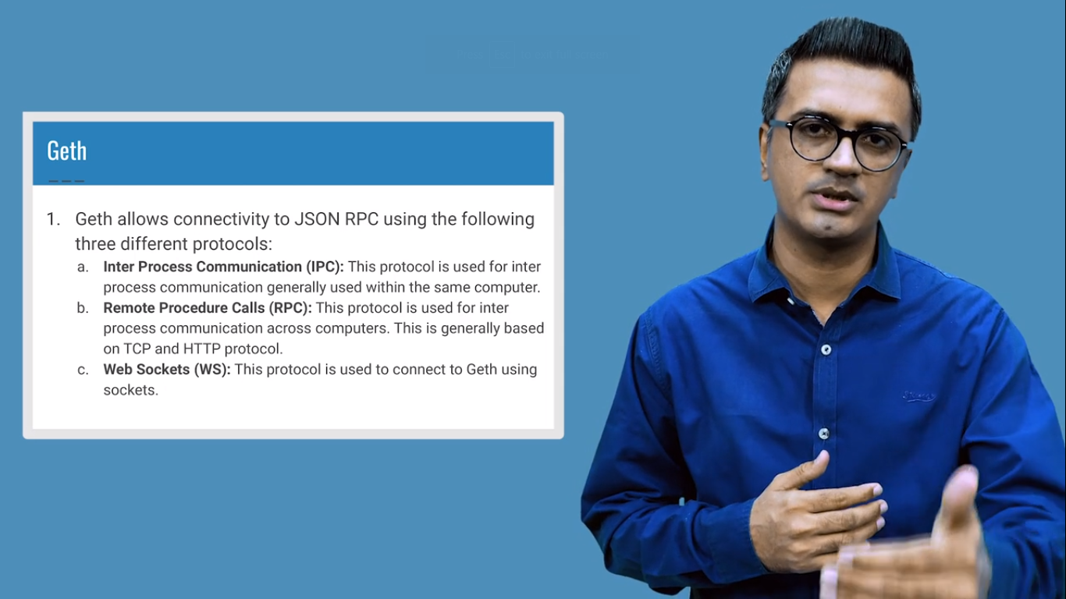

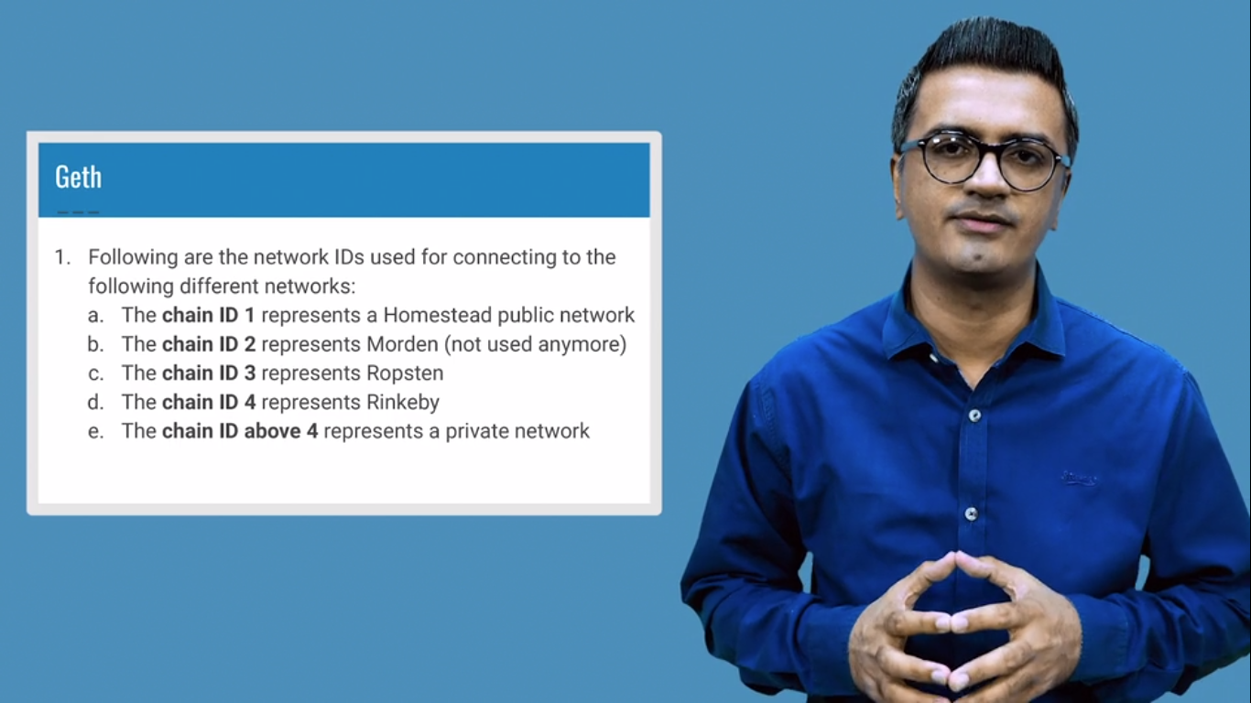

**Creating a Private Network:**

